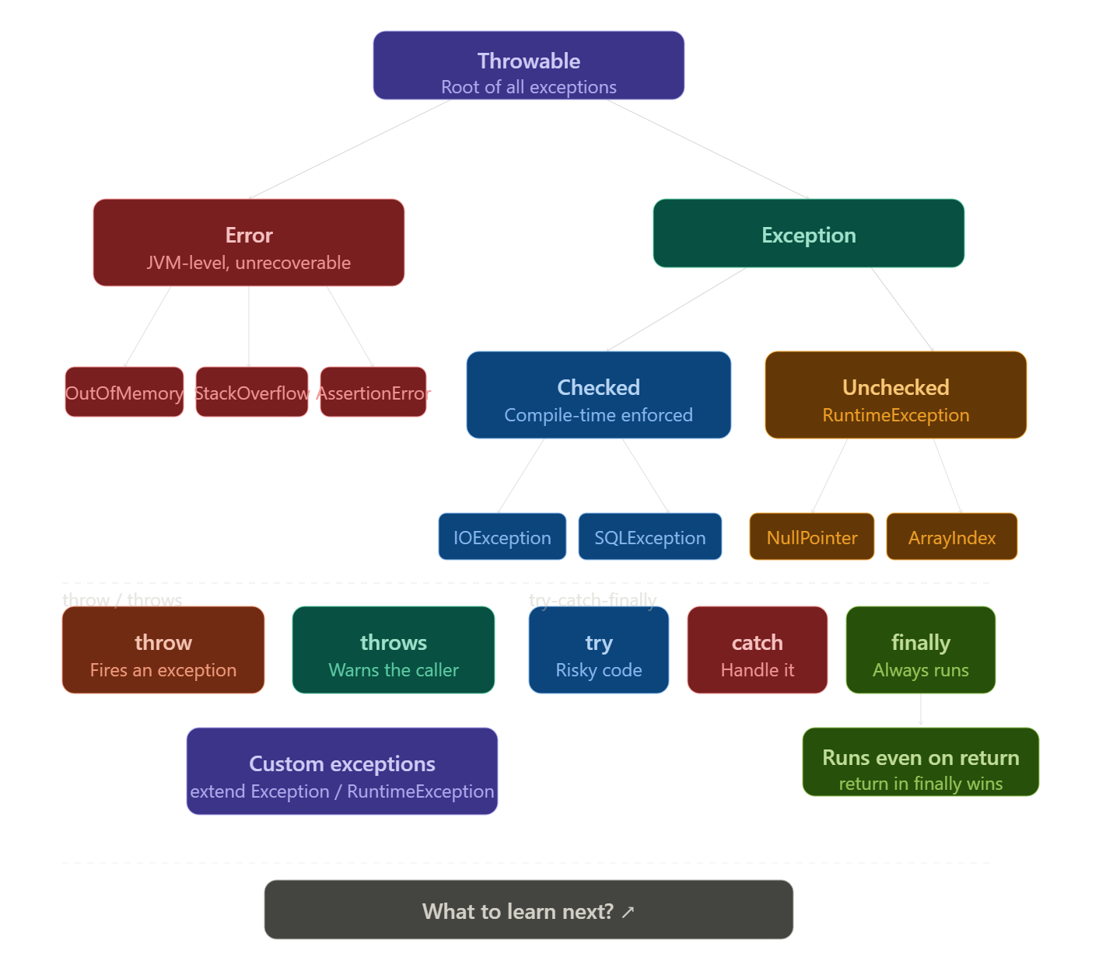
Exception Handling
Exception An unexpected event during program execution that disrupts normal flow. Java provides a structured mechanism to detect, handle, and recover from such events instead of crashing.
Types of Exceptions
Checked — Compiler enforces handling. Must use try-catch or throws. Represent recoverable external conditions. Examples: IOException, SQLException, FileNotFoundException, ClassNotFoundException, InterruptedException
Unchecked — Compiler does NOT enforce. Represent programming bugs. Subclass of RuntimeException. Examples: NullPointerException, ArrayIndexOutOfBoundsException, ArithmeticException, ClassCastException, NumberFormatException, IllegalArgumentException
Error — Serious JVM failures. Never catch. Examples: OutOfMemoryError, StackOverflowError, AssertionError

throw — action, fires one exception instance inside a method body.
throw new IllegalArgumentException("Age cannot be negative");
throws — declaration, warns the caller, can list multiple, only required for checked exceptions.
public void readFile(String path) throws IOException, FileNotFoundException { }
throw does the throwing — throws does the telling.

try-catch-finally
try {
// risky code
} catch (SpecificException e) {
// specific first — broader types always come after
} catch (Exception e) {
// broadest last
} finally {
// always runs — even if return is hit
// only skipped on System.exit() or JVM crash
}
- Catch specific types first — reverse order causes a compile error
- finally always runs even with a return in try/catch — Java saves the value, runs finally, then delivers it
- return inside finally silently overrides the try/catch return — avoid this

Exception Chaining When rethrowing, always pass the original as the cause to preserve the full stack trace:
catch (SQLException e) {
throw new DataAccessException("Failed to load user", e); // e = cause
}
Exception Propagation If not caught in the current method, the exception travels up the call stack until something catches it. If nothing does, the JVM prints the stack trace and terminates the thread.
methodC() throws → methodB() skips → methodA() catches
Abstract Class = Incomplete parent blueprint used for inheritance. Declared using abstract keyword. Cannot be instantiated.
→ Used when multiple related classes share common properties/methods but need different implementations for some behaviors.
→ Can contain:
→ Abstract methods (no body), Concrete methods (with body),Variables / instance fields
→ Constructors, Static methods, Final methods
→ Abstract Method = Method declared without body using abstract; child classes must override it.
abstract void drive();
→ If a class contains at least one abstract method, the class must be declared abstract.
→ Child class must implement all abstract methods, otherwise child also becomes abstract.
→ Cannot create object of abstract class:
Vehicle v = new Vehicle(); // Error
→ Can create child object and use parent reference:
Vehicle v = new Car();
→ Constructors in abstract class are allowed and run when child object is created using super().
→ Abstract Class vs Normal Class
for normal classes we can create objs but for abstract classes we can’t
Normal methods and abstract methods.
→ Abstract Class vs Interface
→ Abstract class can have state, constructors, normal methods
→ Interface mainly defines contract/capabilities
→ Class can extend only one abstract/parent class
→ Class can implement multiple interfaces
→ Cannot declare abstract class as final because abstract needs inheritance, final blocks inheritance.
→ Main purpose: Code reuse + common design + forcing subclasses to implement required behavior.
Inner Classes:
An Inner Class is a class declared inside another class or inside a method.Used when one class is strongly related to another and should exist only inside it.
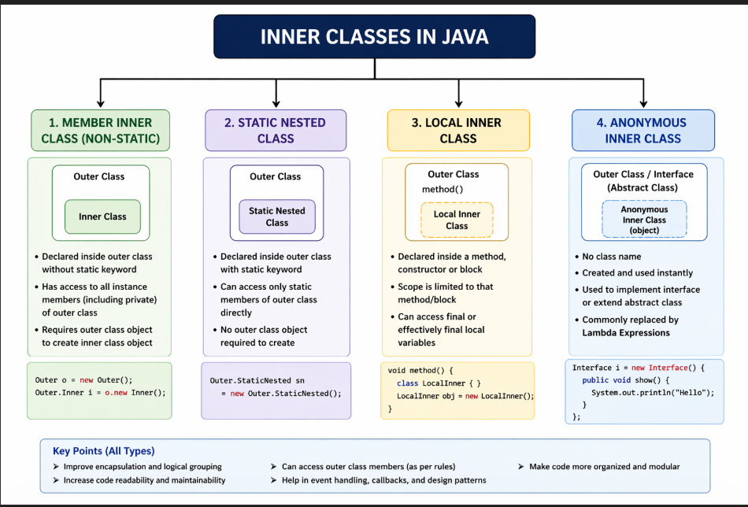
When to use them:
→ Better grouping of related code
→ Cleaner structure
→ Hide helper classes from outside world
→ Access outer class members easily

→ Pass by Value = A copy of the actual value is passed to the method. Changes made inside the method do not affect the original variable.
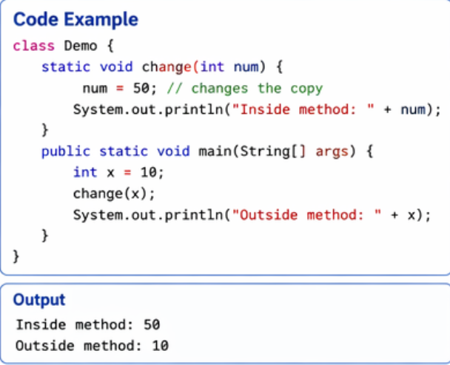

→ Pass by Reference = The reference/address of the original object is passed, so changes to object data inside the method affect the original object.
(Note: In Java, objects behave like reference passing, but technically Java passes reference by value.)
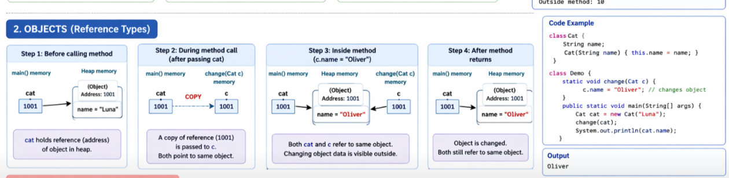
→ Lambda Expression = Short syntax used to implement a functional interface and pass behavior/code as data. Introduced in Java 8.
→ Basic Syntax:
(parameters) -> expression
(parameters) -> { statements; }
→ Functional Interface = Interface containing exactly one abstract method. Lambda expressions work only with functional interfaces.
interface Start {
void run();
}

→ Example using Lambda:
Start s = () -> System.out.println("Car Started");
s.run();
Output:
Car Started
→ s is an interface reference variable. Lambda creates an object that implements the interface internally.
→ Equivalent Anonymous Class:
Start s = new Start() {
public void run() {
System.out.println("Car Started");
}
};
2. interface Add {
int sum(int a, int b);
}
Add a = (x, y) -> x + y;
System.out.println(a.sum(2, 3));
→ Enum = Special datatype used to represent a fixed set of named constants. Internally behaves like a special class.
enum Day {
MONDAY, TUESDAY, WEDNESDAY
}
→ Day = Enum type / custom datatype.
→ MONDAY, TUESDAY, WEDNESDAY = Predefined enum constants (objects/values of type Day).
→ d = Variable of enum type.
Day d = Day.MONDAY;
Meaning: variable d stores the constant MONDAY.
→ Breakdown of above statement:
→ Day = datatype
→ d = variable name
→ Day.MONDAY = enum constant/value
→ Similar to class object creation:
Student s = new Student();
But in enum, objects are already created by Java.
→ No new keyword used with enums.
Day d = new Day(); // Error
→ Enum provides type safety: only declared constants can be assigned.
Day d = Day.TUESDAY; // Valid
Day d = "FRIDAY"; // Invalid
→ Use enums when values are fixed and predefined:
→ Days , Months , Status values , Roles , Directions , Traffic signals
→ Important methods:
Day.values()
Returns all constants.
Day.MONDAY.name()
Returns "MONDAY"
Day.valueOf("MONDAY")
Returns Day.MONDAY
→ Main purpose: Cleaner, safer, readable alternative to int or String constants.
Enum type = class, constants = objects, variable = reference holder.

→ Serialization = Process of converting an object into a byte stream so it can be saved to a file, transferred over network, or stored for later use.
→ Deserialization = Process of converting byte stream back into original object.
→ Main purpose: Preserve object state beyond program execution.

→ Class must implement Serializable interface to allow serialization. It is a marker interface (no methods).
class Student implements Serializable {
}
→ Important Streams:
→ FileOutputStream → Writes bytes to file
→ ObjectOutputStream → Writes objects to file
→ FileInputStream → Reads bytes from file
→ ObjectInputStream → Reads objects from file
→ Serialize single object:
out.writeObject(obj);
→ Deserialize single object:
Student s = (Student) in.readObject();
→ Multiple Objects Serialization = Use multiple writeObject() calls on same stream.
out.writeObject(obj1);
out.writeObject(obj2);
→ Read multiple objects in same order using readObject().
readObject();
readObject();
→ Objects must be read in the exact sequence they were written.
→ Better professional approach: Serialize collection object like ArrayList<Student> instead of fixed multiple objects.
→ transient keyword prevents field from being serialized.
transient String password;
→ static fields are not serialized because they belong to class, not object.
→ Common Exceptions:
→ NotSerializableException → Class not serializable
→ ClassNotFoundException → Class missing during reading
→ InvalidClassException → Version mismatch

Java Programming
ArrayList = Resizable array in Java Collections Framework. Stores elements dynamically and allows fast index-based access.
ArrayList<String> list = new ArrayList<>();
list.add("Apple");
list.add("Banana");
System.out.println(list.get(0));
Output:
Apple
→ Internally uses dynamic array.
→ Best for:
→ Frequent reading/searching , Access using index , Mostly add at end

→ LinkedList = Doubly linked list implementation where each node stores data + next + previous references.
LinkedList<String> list = new LinkedList<>();
list.add("Red");
list.add("Blue");
list.addFirst("Green");
System.out.println(list);
Output:
[Green, Red, Blue]
→ Best for:
→ Frequent insert/delete , Add/remove at beginning , Queue / Deque operations

→ Common Methods (Both):
add() get() set() remove() size() contains() clear() isEmpty()
→ ArrayList = Better Access
→ LinkedList = Better Insertion/Deletion
Java Programming
HashMap, LinkedHashMap, TreeMap in Java
HashMap : HashMap stores entries using hashing.
HashMap<Integer, String> map = new HashMap<>();
Features
→ No duplicate keys
→ One null key allowed
→ Multiple null values allowed
→ No insertion order guaranteed
→ Fast operations
Example
HashMap<Integer,String> map = new HashMap<>();
map.put(101,"Apple");
map.put(102,"Banana");
System.out.println(map.get(101));
Output:
Apple

LinkedHashMap: LinkedHashMap = HashMap + maintains insertion order.
LinkedHashMap<Integer,String> map = new LinkedHashMap<>();
Features
→ Keeps entries in inserted order
→ Slightly slower than HashMap
→ Uses linked structure internally
Example
LinkedHashMap<Integer,String> map = new LinkedHashMap<>();
map.put(3,"C");
map.put(1,"A");
map.put(2,"B");

System.out.println(map);
Output:
{3=C, 1=A, 2=B}

TreeMap: TreeMap stores keys in sorted order.
TreeMap<Integer,String> map = new TreeMap<>();
Features
→ Keys sorted automatically
→ No null key allowed
→ Slower than HashMap
→ Based on Red-Black Tree
Example
TreeMap<Integer,String> map = new TreeMap<>();
map.put(3,"C");
map.put(1,"A");
map.put(2,"B");
System.out.println(map);
Output:
{1=A, 2=B, 3=C}

Common Methods
put(key,value) get(key) remove(key) containsKey(key) containsValue(value)
size() isEmpty() clear() keySet() values() entrySet()
Example Traversal
for(Map.Entry<Integer,String> e : map.entrySet()){
System.out.println(e.getKey()+" "+e.getValue());
}
HashMap = fast unordered, LinkedHashMap = ordered, TreeMap = sorted.
Use HashMap by default, choose LinkedHashMap for order, TreeMap for sorting.
Java Programming
HashSet, LinkedHashSet, TreeSet in Java
HashSet:HashSet uses hashing to store unique elements.
HashSet<String> set = new HashSet<>();
Features
→ No duplicates
→ No insertion order guaranteed
→ Allows one null value
→ Fastest set operations
Example
HashSet<String> set = new HashSet<>();
set.add("Apple");
set.add("Banana");
set.add("Apple");
System.out.println(set);
Output:
[Apple, Banana]

LinkedHashSet: LinkedHashSet = HashSet + maintains insertion order.
LinkedHashSet<String> set = new LinkedHashSet<>();
Features
→ Unique elements
→ Keeps insertion order
→ Slightly slower than HashSet
→ Allows one null
Example
LinkedHashSet<String> set = new LinkedHashSet<>();
set.add("C");
set.add("A");
set.add("B");

System.out.println(set);
Output:
[C, A, B]

4. TreeSet: TreeSet stores unique elements in sorted order.
TreeSet<Integer> set = new TreeSet<>();
Features
→ Unique elements
→ Sorted automatically
→ No null allowed
→ Slower than HashSet
→ Based on Red-Black Tree
Example
TreeSet<Integer> set = new TreeSet<>()
set.add(30);
set.add(10);
set.add(20);
System.out.println(set);
Output:
[10, 20, 30]

5. Common Methods (All Sets)
add() remove() contains() size() isEmpty() clear() iterator()

6. Unique / Important TreeSet Methods
first() last() higher(x) lower(x)
ceiling(x) floor(x)
pollFirst() pollLast()
descendingSet()
Example Traversal
for(String item : set){
System.out.println(item);
}
HashSet = unordered unique, LinkedHashSet = ordered unique, TreeSet = sorted unique.
Use HashSet by default, use LinkedHashSet for order, TreeSet for sorting.

